**FDA Submission**

**Your Name:** Shivank Yadav

**Name of your Device:** PneumoNet

**Algorithm Description**

**1. General Information**

**Intended Use Statement:** Assist Radiologist in classification of Pneumonia on Chest X-ray.

**Indications for Use:** Improve Radiologist's workflow by prioritizing chest X-rays with higher probability of Pneumonia. To be used for patients of both gender with ages between 1-90.

**Device Limitations:** GPU/Cloud Computing Instance may be required with High workload if to be used in Emergency settings. Should not use model for patients older than 90.  **Edema and Consolidation** has a lot of similarity in their mean intensity distributions with that of Pneumonia and thus our model can misclassify here and result in False Positives.

**Clinical Impact of Performance:**

If we are using the device for screening and want minimum false negatives, then we need higher sensitivity(recall). That is no patient who has a disease should be marked negative.

Increasing recall will decrease precision. But if we let precision drop too much, this will result increase in false positives and thus cases of lower interest will be given more priority while being queued for the radiologist to look at.

**2. Algorithm Design and Function**

ALGORITHM IN CLINICAL SETTING

[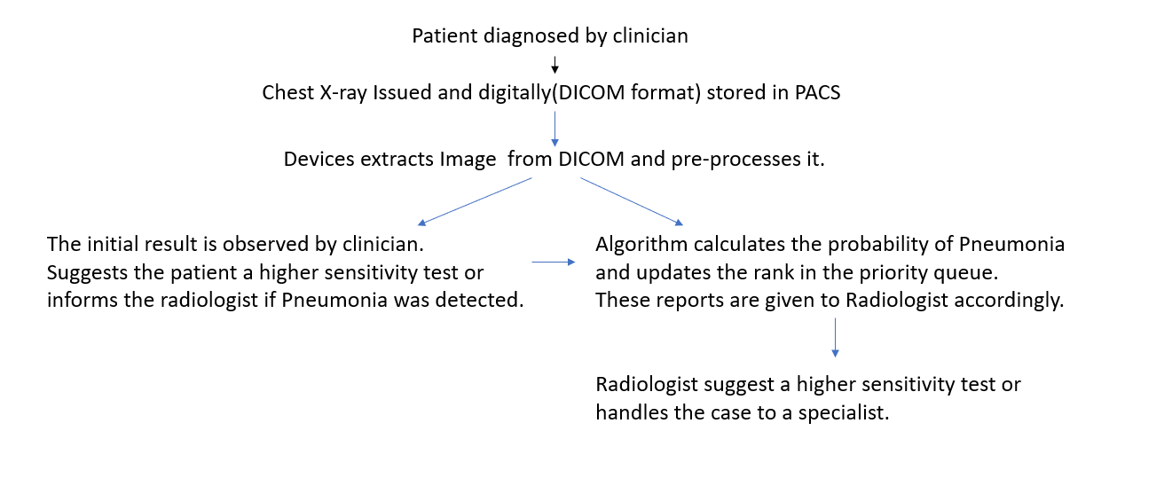](https://github.com/ShivankYadav/PneumoniaDetectionOnChestXray/blob/master/AIHCND_C2_Starter/flowchart.png)**DICOM Checking Steps:** Pydicom module in python library was used to extract Images as well as metadata form DICOM files.

We look at Patient Age, Patient Sex, Patient Position , Modality, Findings and Body Part Examined and check if this matches the distribution of data we trained on.

**Preprocessing Steps:** While Training, the Images were Standardized (using mean and deviation) or rescaled by 1/255.0. Then it was augmented using Keras ImageDataGenerator to account for variance in real world and lack of Data. Finally Resized by (1,244,244,3) and pushed into a modified VGG CNN.

**CNN Architecture:** Used VGG-16 as base model initialized with Imagenet weights. Replaced last layer by combination of dense and Dropout layers as follows: [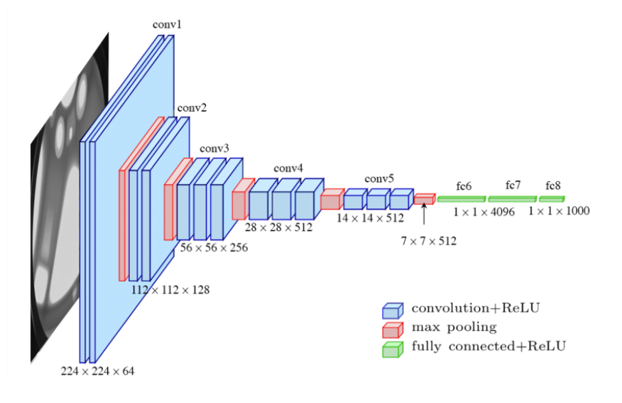](https://github.com/ShivankYadav/PneumoniaDetectionOnChestXray/blob/master/AIHCND_C2_Starter/vgg.png)[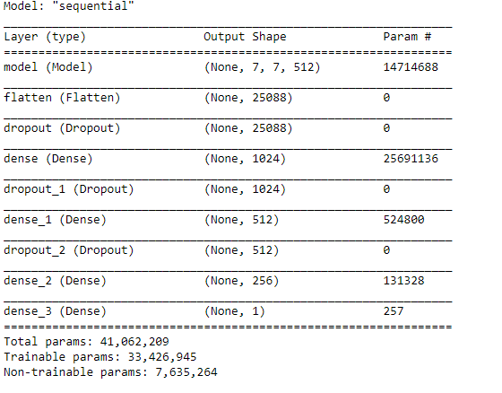](https://github.com/ShivankYadav/PneumoniaDetectionOnChestXray/blob/master/AIHCND_C2_Starter/model.png)

Finetuned the whole network from 15th layer of VGG Net.

**3. Algorithm Training**

**Parameters:**

* Types of augmentation used during training:

Training Set

* Normalization by standardization(using mean and deviation) or just rescalling by 1.0/255.0

* horizontal_flip=True,

* vertical_flip =False,

* height_shift_range=0.1,

* width_shift_range=0.1,

* rotation_range=15,

* shear_range=0.1,

* zoom_range=0.1

Validation set was just Normalized using same technique as training set.

* Batch size : 32 for both validation and training set.
* Optimizer learning rate : 1e-4
* Layers of pre-existing architecture that were frozen : first 16 including input_layer
* Layers of pre-existing architecture that were fine-tuned : All the layers after first 16
* Layers added to pre-existing architecture : Dropout + dense (x3) -> Dense(256) -> Dense(1) // sigmoid layer/output layer

**Algorithm training performance visualization**

[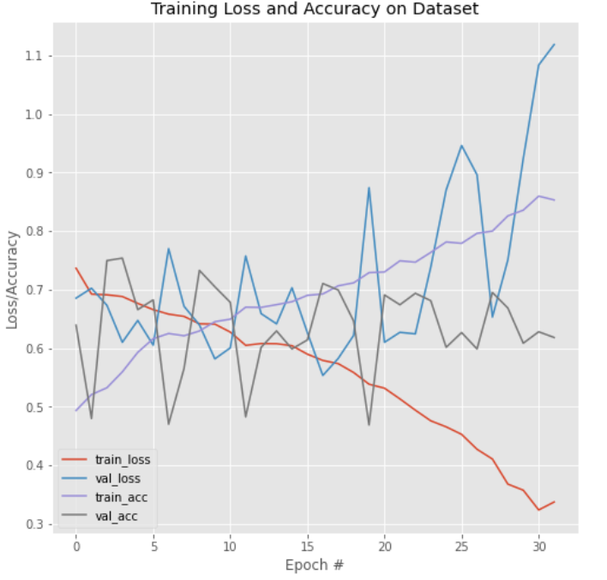](https://github.com/ShivankYadav/PneumoniaDetectionOnChestXray/blob/master/AIHCND_C2_Starter/training_performance.png)

**P-R Curve**

[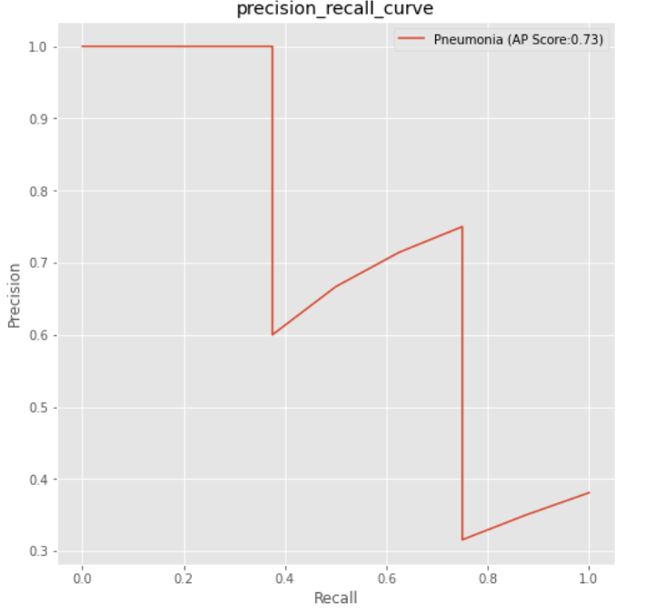](https://github.com/ShivankYadav/PneumoniaDetectionOnChestXray/blob/master/AIHCND_C2_Starter/prc.png)

**AUC Curve** [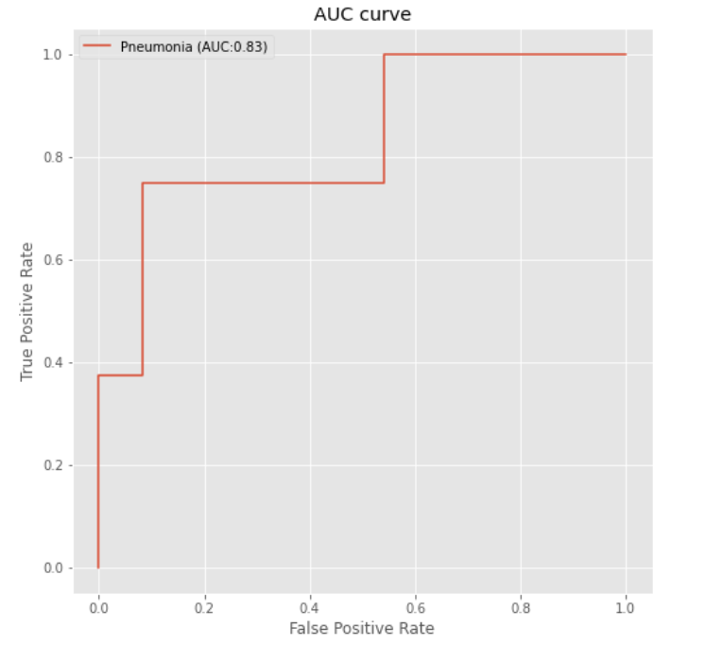](https://github.com/ShivankYadav/PneumoniaDetectionOnChestXray/blob/master/AIHCND_C2_Starter/auc.png)

**Final Threshold and Explanation:**

[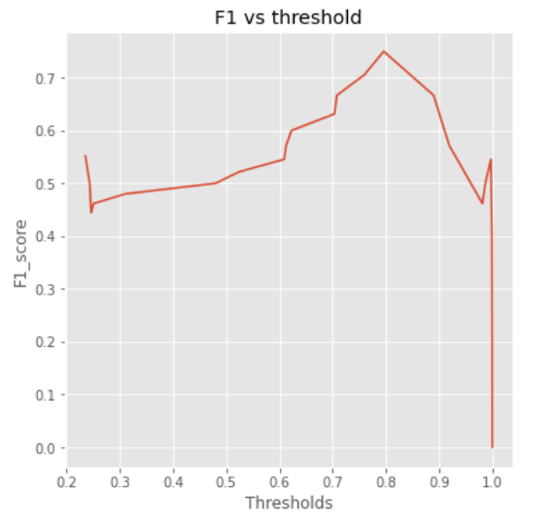](https://github.com/ShivankYadav/PneumoniaDetectionOnChestXray/blob/master/AIHCND_C2_Starter/f1.png)

I chose F1 score as the metrics for this problem because depending on the scenario in which the algorithm is used, both precision and recall can be important factors. Hence, to balance both of them, this metric is used.

The threshold calculated with the best F1 score is 0.7959541

**4. Databases**

We used a part of the [National Institutes of Health Chest X-Ray Dataset](https://www.kaggle.com/nih-chest-xrays/data). The NIH Chest X-ray Dataset is comprised of 112,120 X-ray images with disease labels from 30,805 unique patients. To create these labels, the authors used Natural Language Processing to text-mine disease classifications from the associated radiological reports. The labels are expected to be >90% accurate and suitable for weakly-supervised learning. The original radiology reports are not publicly available but you can find more details on the labelling process in this Open Access paper: ["ChestX-ray8: Hospital-scale Chest X-ray Database and Benchmarks on Weakly-Supervised Classification and Localization of Common Thorax Diseases."](https://www.nih.gov/news-events/news-releases/nih-clinical-center-provides-one-largest-publicly-available-chest-x-ray-datasets-scientific-community)

We have 1431 cases from 112120 cases which have Pneumonia as a finding. That is 1.2763110952550838% of whole dataset. We will distribute these into training and validation sets accordingly

**Description of Training**

**Dataset:** [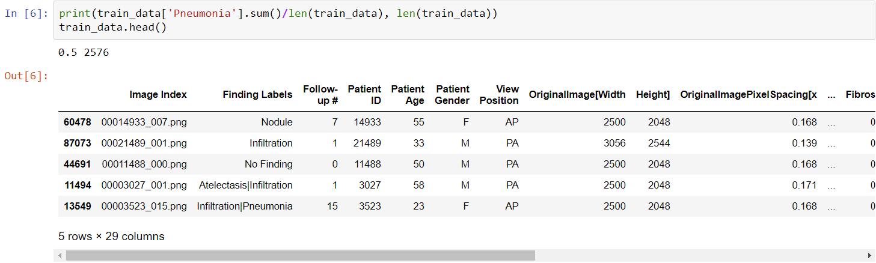](https://github.com/ShivankYadav/PneumoniaDetectionOnChestXray/blob/master/AIHCND_C2_Starter/trainingds.png)

We used 2576 images for training set with 50 percent of these having Pneumonia as a finding.

**Description of Validation**

**Dataset:** [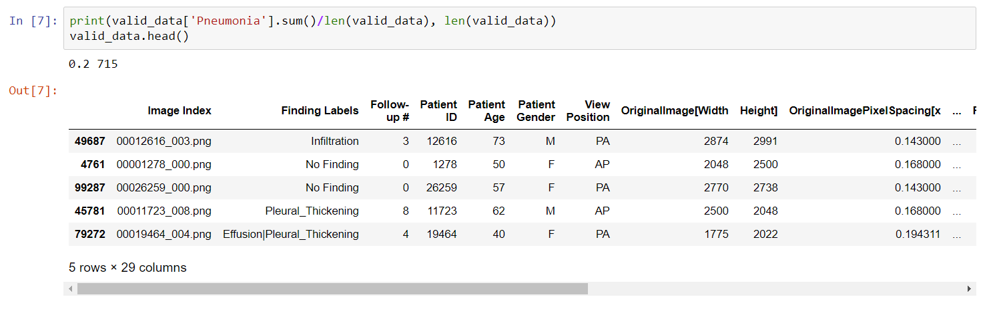](https://github.com/ShivankYadav/PneumoniaDetectionOnChestXray/blob/master/AIHCND_C2_Starter/validds.png)

We used 715 validation images, 20 percent of these having Pneumonia which is similar to prevalence of Pneumonia in clinical setting.

**5. Ground Truth**

Here, we used NLP extracted Radiology report as labelling.

Data limitations:

The image labels are NLP extracted so there could be some erroneous labels but the NLP labelling accuracy is estimated to be >90%. Very limited numbers of disease region bounding boxes (See BBoxlist2017.csv)

Chest x-ray radiology reports are not anticipated to be publicly shared. Parties who use this public dataset are encouraged to share their “updated” image labels and/or new bounding boxes in their own studied later, maybe through manual annotation

**6. FDA Validation Plan**

Approach FORTIS hospital to be our clinical partner.

**Patient Population Description for FDA Validation Dataset:** Need access to DICOM data containing Chest X-rays of patients of age 20 to 80 in both AP and PA orientations.

**Ground Truth Acquisition Methodology:** Assign a team of 2 or 3 radiologists (silver standard) to label the validation data.

**Algorithm Performance Standard:** F1 score is the metric of choice because we can have multiple scenarios for this device where precision or recall is important respectively.

Aside from comparing with our silver standard we also want to achieve F1 score better than the average F1 score(0.387) of group of 4 radiologists as observed in [literature](https://arxiv.org/pdf/1711.05225.pdf).

*Note:* Increase in precision decreases recall. We may want higher precision or recall according to the scenario.

Eg. If we are using the device for screening and want minimum false negatives, then we need higher sensitivity(recall). That is no patient who has a disease should be marked negative.

Increasing recall will decrease precision. But if we let precision drop too much, this will result increase in false positives and thus cases of lower interest will be given more priority while being queued for the radiologist to look at.

Here we can choose corresponding threshold with higher precision from Precision-Recall curve or we can use F1 score that balances both precision and recall.